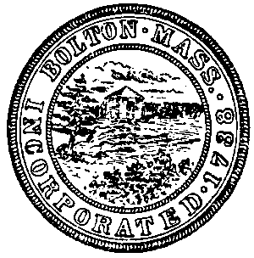 |  |  |  |  |  | Town of Bolton
 |  |  |  |  |  | Bolton, Massachusetts
 |  |  |  |  |  | Town Hall, 663 Main Street, Bolton, MA 01740
 |  |  |  |  |  |  |  |  |  |  |  | Phone 978-779-2297 Fax 978-779-5461
INVITATION FOR PROPOSAL AND BID
TECHNICAL SUPPORT TO BOLTON TOWN HALL
June 12, 2017 11:00 a.m.

CTS Services Inc.
260 Maple Street
Bellingham, Ma 02019

Avatar Computing, Inc.
146 Main Street, Suite 402
Worcester, MA 01608

CMGEEKS, Inc. Awarded ($21,000.00)
243 Bullard Road
Oakham, Ma 01068

Ockers Company
830 West Chestnut Street
Brockton, Ma 02301

Ayacht Technology Solutions
289 Seven Bridge Road
Lancaster, MA 01523

Protocol Networks Inc.
15 Shore Drive
Johnston, RI 02919

