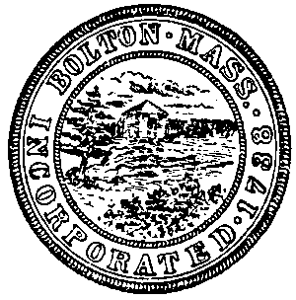 |  |  |  |  |  | Town of Bolton
 |  |  |  |  |  | Bolton, Massachusetts
 |  |  |  |  |  | Town Hall, 663 Main Street, Bolton, MA 01740
 |  |  |  |  |  |  |  |  |  |  |  | Phone 978-779-2297 Fax 978-779-5461
INVITATION FOR PROPOSAL AND BID
TECHNICAL SUPPORT TO BOLTON PUBLIC SAFETY BUILDING
June 12, 2017 11:00 a.m.

Ayacht Technology Solutions
289 Seven Bridge Road
Lancaster, MA 01523

Ockers Company
830 West Chestnut Street
Brockton, Ma 02301

CMGEEKS, Inc. Awarded ($38,088.00)
243 Bullard Road
Oakham, Ma 01068

Protocol Networks Inc.
15 Shore Drive
Johnston, RI 02919

