Temporary Leash Requirement
May 2024
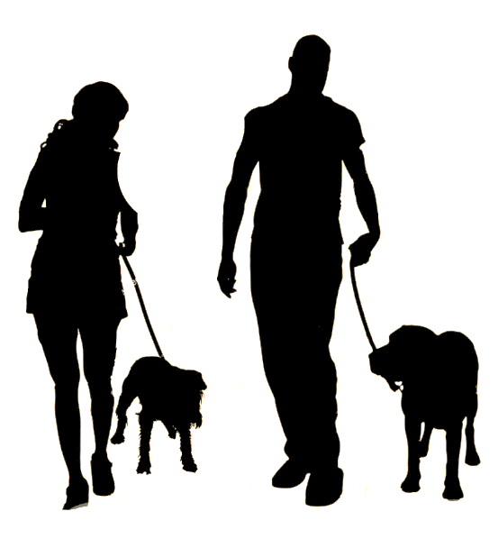

Dogs must be on a leash at this conservation property.
*The Conservation Commission has contracted work to carry out necessary maintenance of earthen dams on site. During this time portions of the trail around the ponds will be temporarily closed. For your dog’s safety as well as the safety of the workers, the Conservation Commission has put in place a leash requirement for the month of May 2024 at this conservation property until work has been completed.*

