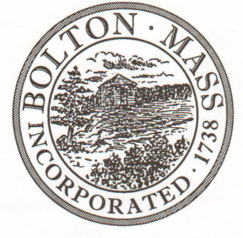
PUBLIC MEETING NOTICE
TO OFFICE OF THE

Received by Town Clerk:

Date: _______________________________

Time AM/PM

Posted by Town Clerk - Town Hall and Website:

Date: _______________________________

Time AM/PM

BOLTON TOWN CLERK

TIME STAMP

BOARD: | Board of Assessors

MEETING PUBLIC HEARING (Please underline appropriately)

DATE: | September 18, 2018 |  | TIME: | 6:00 PM

LOCATION: | Town Hall, Upstairs Side Table

REQUESTED BY: | Cynthia Bradbury,  Assistant Assessor | DATE: | 08/22/2018

NOTE: ALL MEETING NOTICES AND LIST OF TOPICS MUST BE FILED AND TIME STAMPED IN THE TOWN CLERK’S OFFICE AND POSTED 48 HOURS IN ADVANCE OF THE MEETINGS EXCLUDING SATURDAY, SUNDAYS AND HOLIDAYS.

LIST OF TOPICS

- Review FY2019 Revaluation Status and any required signatures with David Manzello.
- Discuss the FY2019 Public Disclosure process.
- Discuss Conservation Restriction for 58 Old Harvard Road.
- General Departmental business and signatures.

