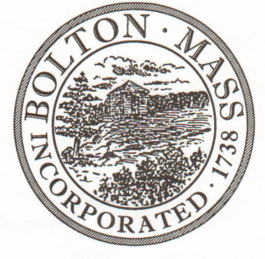
PUBLIC MEETING NOTICE
TO OFFICE OF THE

Received by Town Clerk:

Date: _______________________________

Time AM/PM

Posted by Town Clerk - Town Hall and Website:

Date: _______________________________

Time AM/PM

BOLTON TOWN CLERK

TIME STAMP

BOARD: | Parks and Recreation Commission

MEETING PUBLIC HEARING (Please underline appropriately)

DATE: | Thursday, September 6, 2018 |  | TIME: | 7:00 p.m.

LOCATION: | Houghton Building, 697 Main Street, Bolton
REQUESTED BY: |  | Laura Roberts | DATE: | 8/31/18

NOTE: ALL MEETING NOTICES AND LIST OF TOPICS MUST BE FILED AND TIME STAMPED IN THE TOWN CLERK’S OFFICE AND POSTED 48 HOURS IN ADVANCE OF THE MEETINGS EXCLUDING SATURDAY, SUNDAYS AND HOLIDAYS.

LIST OF TOPICS / AGENDA

Approve Minutes from August 2, 2018 Meeting 7:00 PM

Field and event requests 7:05 PM
- Nashoba Boys Youth Lacrosse
- Nashoba Girls Youth Lacrosse
- FSS Soccer
- Murphy Court – AAU Team

Parks & Recreation Business 7:10 PM
- Bolton COA Walk
- Halloween Planning and Roles
- Property Updates
- Veteran’s Day Overview
- Budget Update
- Items for Future agendas

Next Meeting: Thursday, October 4, 2018, 7 PM

*Times on the agenda are approximate.

