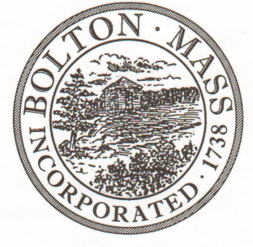
PUBLIC MEETING NOTICE
TO OFFICE OF THE

Received by Town Clerk:

Date: _______________________________

Time AM/PM

Posted by Town Clerk - Town Hall and Website:

Date: _______________________________

Time AM/PM

BOLTON TOWN CLERK

TIME STAMP

BOARD: | Parks and Recreation Commission

MEETING PUBLIC HEARING (Please underline appropriately)

DATE: | Thursday, September 20, 2018 |  | TIME: | 7:30 p.m.

LOCATION: | Houghton Building, 697 Main Street, Bolton
REQUESTED BY: |  | Laura Roberts | DATE: | 9/7/18

NOTE: ALL MEETING NOTICES AND LIST OF TOPICS MUST BE FILED AND TIME STAMPED IN THE TOWN CLERK’S OFFICE AND POSTED 48 HOURS IN ADVANCE OF THE MEETINGS EXCLUDING SATURDAY, SUNDAYS AND HOLIDAYS.

LIST OF TOPICS / AGENDA

Planning meeting: Annual Halloween Party and Parade 7:30 PM

Next Meeting: Thursday, October 4, 2018, 7 PM

*Times on the agenda are approximate.

