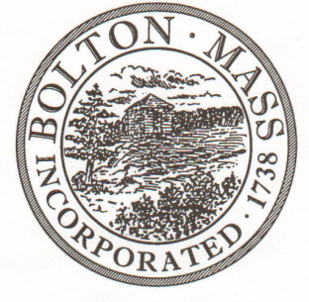
PUBLIC MEETING NOTICE
TO OFFICE OF THE

Received by Town Clerk:

Date: _______________________________

Time AM/PM

Posted by Town Clerk - Town Hall and Website:

Date: _______________________________

Time AM/PM

BOLTON TOWN CLERK

TIME STAMP

BOARD: | Parks and Recreation Commission

MEETING PUBLIC HEARING (Please underline appropriately)

DATE: | Thursday, June 28, 2018 |  | TIME: | 7:00 p.m.

LOCATION: | Houghton Building, 697 Main Street

REQUESTED BY: | Laura Roberts | DATE: | 6/25/18

NOTE: ALL MEETING NOTICES AND LIST OF TOPICS MUST BE FILED AND TIME STAMPED IN THE TOWN CLERK’S OFFICE AND POSTED 48 HOURS IN ADVANCE OF THE MEETINGS EXCLUDING SATURDAY, SUNDAYS AND HOLIDAYS.

LIST OF TOPICS / AGENDA
- Elect Secretary and Treasurer 7:00 PM

- Review and Approve Outstanding Meeting Minutes (February, March, April, May)

- Field and event requests 7:05 PM
- PMC Ride September 23rd – Derby Field Request
- Back Yard Bolton - EDC Farmers Market – Town Common Event Request
- Artist Open Studio – September 15/16 – Town Common Event Request
- Democratic Town Committee Picnic – Town Common Event Request

- Bolton Conservation Trust – Town Common Property Update 7:30 PM

- Field and Event Requests Continued 7:50 PM
- Over the Hill Soccer - Forbush Field Request
- Pilates – Town Common Event Request
- Family Picnic – Town Common Event Request
- Bolton Dad’s Softball League – Memorial Field Request
- Summer Soccer – Horse Ring Field Request

- Bolton Youth Baseball 8:00 PM
- Memorial Field Light Project
- Field release process

- P&R Business 8:20 PM
- Pond Park Brush Clearing Update
- Memorial Field Playground Equipment Update
- Memorial Field Volleyball Net replacement?
- Budget Update
- Summer Movie on the Common
- Summer Concerts on the Common
- Town Common event logistics
  - Trash & Recycling
  - Crosswalk Signage
  - Parking Map
- Halloween Planning Team
- Items for Future Agendas

- Next Meeting Date – Thursday, August 2, 2018

*Times on the agenda are approximate.

