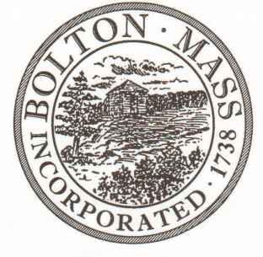
PUBLIC MEETING NOTICE
TO OFFICE OF THE
Received by Town Clerk:

Date: _______________________________
Time AM/PM
Posted by Town Clerk - Town Hall and Website:

Date: _______________________________
Time AM/PM

BOLTON TOWN CLERK

TIME STAMP
BOARD: | Parks and Recreation Commission

MEETING PUBLIC HEARING (Please underline appropriately)
DATE: | Tuesday, March 10th 2020 |  | TIME: | 7:00 p.m.

LOCATION: | Town Hall – Meeting Table
REQUESTED BY: |  | Ed Sterling | DATE: | 3/5/2020

NOTE: ALL MEETING NOTICES AND LIST OF TOPICS MUST BE FILED AND TIME STAMPED IN THE TOWN CLERK’S OFFICE AND POSTED 48 HOURS IN ADVANCE OF THE MEETINGS EXCLUDING SATURDAY, SUNDAYS AND HOLIDAYS.

LIST OF TOPICS / AGENDA

7.00 - Approve minutes from February Meeting

7.05 - Property Updates
- Spring Field Opening
- Murphy Court Lights
- Derby Field

7.20 - Financial Update
7.25 - Swim Program 2020
7.35 – Easter Planning
-Coronavirus

7.55 – Continue to review revised Field Use Policies and Fees

8.15 – Mosquito Response Committee

8.20 – New Business

Items for next agenda

Next Meeting: Tuesday April 14th 2020
*Times on the agenda are approximate.

