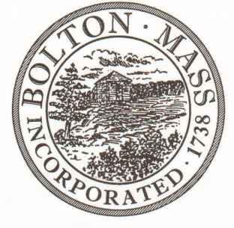
PUBLIC MEETING NOTICE
TO OFFICE OF THE
Received by Town Clerk:

Date: _______________________________
Time AM/PM
Posted by Town Clerk - Town Hall and Website:

Date: _______________________________
Time AM/PM

BOLTON TOWN CLERK

TIME STAMP
BOARD: | Parks and Recreation Commission

MEETING PUBLIC HEARING (Please underline appropriately)
DATE: | Tuesday, February 11th 2020 |  | TIME: | 7:00 p.m.

LOCATION: | Town Hall – Meeting Table
REQUESTED BY: |  | Ed Sterling | DATE: | 2/5/2020

NOTE: ALL MEETING NOTICES AND LIST OF TOPICS MUST BE FILED AND TIME STAMPED IN THE TOWN CLERK’S OFFICE AND POSTED 48 HOURS IN ADVANCE OF THE MEETINGS EXCLUDING SATURDAY, SUNDAYS AND HOLIDAYS.

LIST OF TOPICS / AGENDA

7pm - Approve minutes from January Meeting

7.05 - Property Updates
Persons Park
- Signage, cost and design confirmation
- Cottage status
Forbush Parking
Memorial Field
- Electric Bill BYB
- Triple Play
- Electric Timer - Basketball

Town Common - Music License/Summer Concerts
7.50 - Financial Update
7.55 - Revolving Account Article
8.10 – Swim Program 2020

8.20 – Continue to review revised Field Use Policies and Fees

8.40 – Easter Planning

Items for next agenda

Next Meeting: Tuesday, March 10th 2020
*Times on the agenda are approximate.

