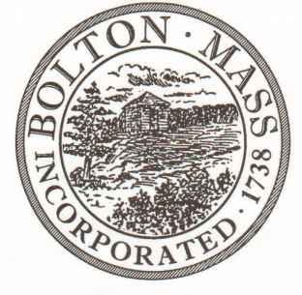
PUBLIC MEETING NOTICE
TO OFFICE OF THE
Received by Town Clerk:

Date: _______________________________
Time AM/PM
Posted by Town Clerk - Town Hall and Website:

Date: _______________________________
Time AM/PM

BOLTON TOWN CLERK

TIME STAMP

BOARD: | Parks and Recreation Commission

MEETING PUBLIC HEARING (Please underline appropriately)
DATE: | Tuesday, January 14th 2020 |  | TIME: | 7:00 p.m.

LOCATION: | Town Hall – Selectmen Room
REQUESTED BY: |  | Ed Sterling | DATE: | 1/8/2020

NOTE: ALL MEETING NOTICES AND LIST OF TOPICS MUST BE FILED AND TIME STAMPED IN THE TOWN CLERK’S OFFICE AND POSTED 48 HOURS IN ADVANCE OF THE MEETINGS EXCLUDING SATURDAY, SUNDAYS AND HOLIDAYS.

LIST OF TOPICS / AGENDA

7pm - Approve minutes from December’s Meeting

7.05 - Property Updates
- Town Common Clear up
- Forbush Parking
7.15 - Financial Update
7.20 – Continue to review revised Field Use Policies and Fees

7.40 – Commission’s Roles 2020

8.00 - Revolving /stabilising account

8.15 – Approve Annual Report

Items for next agenda

Next Meeting: Tuesday, February 11th 2020
*Times on the agenda are approximate.

