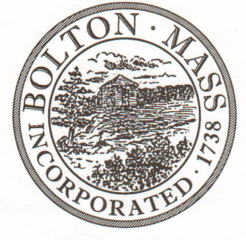
PUBLIC MEETING NOTICE
TO OFFICE OF THE

Received by Town Clerk:

Date: _______________________________

Time AM/PM

Posted by Town Clerk - Town Hall and Website:

Date: _______________________________

Time AM/PM

BOLTON TOWN CLERK

TIME STAMP

BOARD: | Parks and Recreation Commission

MEETING PUBLIC HEARING (Please underline appropriately)
DATE: | Tuesday, December 10th 2019 |  | TIME: | 7:00 p.m.

LOCATION: | Town Hall – Selectmen Room
REQUESTED BY: |  | Laura Roberts | DATE: | 12/4/2019

NOTE: ALL MEETING NOTICES AND LIST OF TOPICS MUST BE FILED AND TIME STAMPED IN THE TOWN CLERK’S OFFICE AND POSTED 48 HOURS IN ADVANCE OF THE MEETINGS EXCLUDING SATURDAY, SUNDAYS AND HOLIDAYS.

LIST OF TOPICS / AGENDA

7pm - Approve minutes from October & November Meeting

7.10 - Property Updates
- Memorial Field Lighting Project
- Persons Park - Sign
7.20 – Continue to review revised Field Use Policies and Fees
7.40 - Amendment of Lifeguard and Swim Instructor hourly rate

7.50 - 2020 Calendar of Events

8.10 – Commission’s Roles 2020

8.20 – Communication

8.30 – Town Common Tree Lighting & Menorah - Debrief

8.40 – 2020 Spring Field Use form deadline

8.45 – Review yearly maintenance checks

8.50 – Annual Report

9.00 – Snowman Competition – Cabin Fever Winter Festival

Items for next agenda

Next Meeting: Tuesday, January 14th
*Times on the agenda are approximate.

