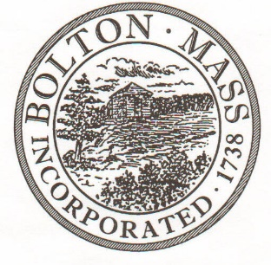
PUBLIC MEETING NOTICE
TO OFFICE OF THE

Received by Town Clerk:

Date: __04/10/2024 01:00 PM___

Time AM/PM

Posted by Town Clerk - Town Hall and Website:

Date: _04/10/2024 01:30 PM_________

Time AM/PM

BOLTON TOWN CLERK

TIME STAMP
BOARD: | Ballot Test for Town Election

MEETING PUBLIC HEARING (Please underline appropriately)

DATE: | April 29 , 2024 |  | TIME: | 1 PM

LOCATION: | Town Hall – Select Board Meeting Room – 1st Floor

REQUESTED BY: | Pam Powell |  | 04/10/2024

NOTE: Notices and List of Topics or Agendas are to be posted 48 hours in advance of the meetings excluding Saturdays, Sundays and legal holidays. Please keep in mind the Town Clerk’s hours of operation and make necessary arrangements to be sure your posting and agenda is made in adequate time.

LIST OF TOPICS / AGENDA

- Manually tally test ballots on paper
- Run Test Ballots in DS200 Voting tabulator
- Compare results with manual tally

