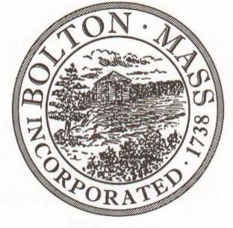
PUBLIC MEETING NOTICE

Received by Town Clerk:

Date: _______________________________

Time AM/PM

Posted by Town Clerk - Town Hall and Website:

Date: _______________________________

Time AM/PM

TO OFFICE OF THE
BOLTON TOWN CLERK

TIME STAMP
BOARD: | Human Services and Safety

MEETING PUBLIC HEARING (Please underline appropriately)
DATE: | May 9, 2018 |  | TIME: | 6 PM

LOCATION: | Houghton Building

REQUESTED BY: | Laura Roberts | Date filed with TC: | 5/4/18

NOTE: Notices and List of Topics or Agendas are to be posted 48 hours in advance of the meetings excluding Saturdays, Sundays and legal holidays. Please keep in mind the Town Clerk’s hours of operation and make necessary arrangements to be sure your posting and agenda is made in adequate time.

LIST OF TOPICS / AGENDA

- Survey to Prioritize Forum Topics

- Budget Update

- Other business

- Topics for Next Agenda

