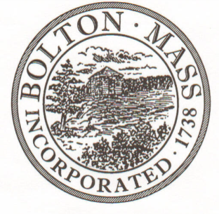
PUBLIC MEETING NOTICE
TO OFFICE OF THE

Received by Town Clerk:

Date: _______________________________

Time AM/PM

Posted by Town Clerk - Town Hall and Website:

Date: _______________________________

Time AM/PM

BOLTON TOWN CLERK

TIME STAMP
BOARD: | HISTORICAL COMMISSION

MEETING PUBLIC HEARING (Please underline appropriately)

DATE: | 12/04/2019 |  | TIME: | 6:00PM

LOCATION: | Town Hall / Selectmen Room or 2nd floor Table

REQUESTED BY: | M. B. Remington, Chairman | Date filed  to TC: | 11/26/2019

NOTE: Notices and List of Topics or Agendas are to be posted 48 hours in advance of the meetings excluding Saturdays, Sundays and legal holidays. Please keep in mind the Town Clerk’s hours of operation and make necessary arrangements to be sure your posting and agenda is made in adequate time.

LIST OF TOPICS / AGENDA

Updates/Public Comment:
Minutes – 11/06/19 (AC)
Town Center MassWorks project update & discussion
Review Portico TY letter
Pan Bollards: new order update; winter damage protection

Administrivia:
Mail –
Budget Report –Treasurer, Alice Coggeshall
BHC Membership – 2 new members needed

New Topics/Public Discussion:
Preliminary discussion re: possible Scout project
2020 projects - new and ongoing
plaques for Pan & Center resources
Next proposed District

