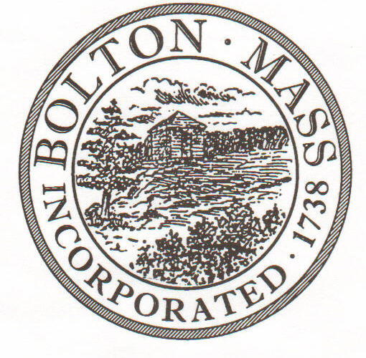
PUBLIC MEETING NOTICE
TO OFFICE OF THE
Received by Town Clerk:

Date: _______________________________
Time AM/PM
Posted by Town Clerk - Town Hall and Website:

Date: _______________________________
Time AM/PM

BOLTON TOWN CLERK

TIME STAMP
BOARD: | Ag Com

MEETING PUBLIC HEARING (Please underline appropriately)
DATE: | August 19, 2019 |  | TIME: | 7pm

LOCATION: | Houghton Bldg

REQUESTED BY: | Conor Nagle | Date filed with TC: | 8/13/2019

NOTE: Notices and List of Topics or Agendas are to be posted 48 hours in advance of the meetings excluding Saturdays, Sundays and legal holidays. Please keep in mind the Town Clerk’s hours of operation and make necessary arrangements to be sure your posting and agenda is made in adequate time.

LIST OF TOPICS / AGENDA

Agenda items will be taken up, giving priority to those for which members of the public are present:

  - Approval of meeting minutes
  - CSA raffle status
  - Potential new members?
  - Bolton Fair recap
  - Backyard Bolton
  - Town Masterplan
  - Fiddler’s Green
  - Goals for FY2020

