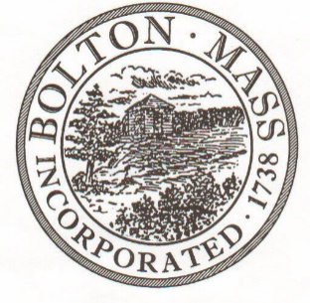
PUBLIC MEETING NOTICE
TO OFFICE OF THE

Received by Town Clerk:

Date: _______________________________

Time AM/PM

Posted by Town Clerk - Town Hall and Website:

Date: _______________________________

Time AM/PM

BOLTON TOWN CLERK

TIME STAMP
BOARD: | Advisory Committee

MEETING PUBLIC HEARING (Please underline appropriately)
DATE: | Tuesday, February 4th, 2020 |  | TIME: | 6:30 PM

LOCATION: | Town Hall, Selectmen’s Room, 663 Main Street

REQUESTED BY: | Jenny Jacobsen | Date filed with TC: | 1/9/20

Advisory Committee Meeting Agenda

Tuesday, February 4th, 2020

6:30 p.m.

Selectmen’s Room, Town Hall, 663 Main Street

Tuesday, February 4th, 2020 at 6:30PM in Town Hall

6:30 – 6:50 p.m. Council on Aging – 541 (Lisa D’Eon/Panny Gerken)
6:50 – 7:20 p.m. Town Clerk – 161, 162, 163 (Pam Powell)
7:20 – 7:40 p.m. MIS – 155 (Travis McKenzie/Paul McKenzie)
7:40 – 8:00 p.m. Parks & Rec – 630, 650 (Lauren Cilley/Ed Sterling)
8:00 – 8:20 p.m. Conservation Commission – 171 (Rebecca Longvall)
Advisory Committee business (e.g., meeting minutes)

