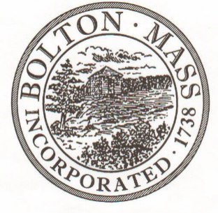
PUBLIC MEETING NOTICE
TO OFFICE OF THE

Received by Town Clerk:

Date: _______________________________

Time AM/PM

Posted by Town Clerk - Town Hall and Website:

Date: _______________________________

Time AM/PM

BOLTON TOWN CLERK

TIME STAMP
BOARD: | Advisory Committee

MEETING PUBLIC HEARING (Please underline appropriately)
DATE: | Tuesday, February 18th, 2020 |  | TIME: | 6:30 PM

LOCATION: | Town Hall, Selectmen’s Room, 663 Main Street

REQUESTED BY: | Jenny Jacobsen | Date filed with TC: | 2/10/20

Advisory Committee Meeting Agenda

Tuesday, February 18th, 2020

6:30 p.m.

Selectmen’s Room, Town Hall, 663 Main Street

Tuesday, February 18th, 2020 at 6:30PM in Town Hall

6:30 – 7:00 p.m. Treasurer/Collector/HR/Benefits – 145, 146, 147, 710, 752, 911, 913, 914, 915, 916 (Kristen Noel)
7:00 – 7:45 p.m. Town Administrator – 122, 123, 151, 192, 194, 195, 243, 244, 303, 440, 912, 945 (Don Lowe)
7:45 – 8:30 p.m. Discussion with Town Administrator regarding FY21 capital recommendations
8:30 – 8:35 p.m. Advisory – 131, Reserve Fund – 132
8:35 – end Advisory Committee business (e.g., meeting minutes)

