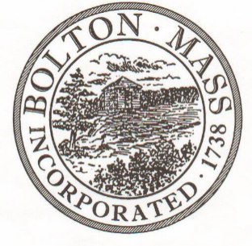
PUBLIC MEETING NOTICE
TO OFFICE OF THE

Received by Town Clerk:

Date: _______________________________

Time AM/PM

Posted by Town Clerk - Town Hall and Website:

Date: _______________________________

Time AM/PM

BOLTON TOWN CLERK

TIME STAMP
BOARD: | Advisory Committee

MEETING PUBLIC HEARING (Please underline appropriately)
DATE: | Tuesday, February 11th, 2020 |  | TIME: | 6:30 PM

LOCATION: | Town Hall, Selectmen’s Room, 663 Main Street

REQUESTED BY: | Jenny Jacobsen | Date filed with TC: | 1/9/20

Advisory Committee Meeting Agenda

Tuesday, February 11th, 2020

6:30 p.m.

Selectmen’s Room, Town Hall, 663 Main Street

Tuesday, February 11th, 2020 at 6:30PM in Town Hall

6:30 – 6:40 p.m. Economic Development Committee – 182 (Erik Neyland)
6:40 – 7:10 p.m. Library-610 (Robert Zak/Tricia Nerron/Kelly Collins)
7:10 p.m. – 7:15 p.m. Moderator-114 (Doug Storey)
7:15 p.m. Advisory Committee business (e.g., meeting minutes)

