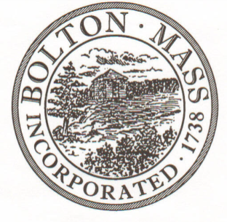
PUBLIC MEETING NOTICE
TO OFFICE OF THE

Received by Town Clerk:

Date: _______________________________

Time AM/PM

Posted by Town Clerk - Town Hall and Website:

Date: _______________________________

Time AM/PM

BOLTON TOWN CLERK

TIME STAMP
BOARD: | HISTORICAL COMMISSION

MEETING PUBLIC HEARING (Please underline appropriately)

DATE: | 01/15/2020 |  | TIME: | 6:00PM

LOCATION: | Town Hall / Selectmen Room or 2nd floor Table

REQUESTED BY: | M. B. Remington, Chairman | Date filed  to TC: | 01/07/2020

NOTE: Notices and List of Topics or Agendas are to be posted 48 hours in advance of the meetings excluding Saturdays, Sundays and legal holidays. Please keep in mind the Town Clerk’s hours of operation and make necessary arrangements to be sure your posting and agenda is made in adequate time.

LIST OF TOPICS / AGENDA

Updates/Public Comment:
Minutes – 11/06/19 (AC); 12/04/19 (BB)
Bollards order & storage
GAR flag markers – resume in April

Administrivia:
Mail –
Budget Report –Treasurer, Alice Coggeshall; FY20 projects
BHC Membership – introduction
Portico completion letter – review
2019 Annual Report - review

New Topics/Public Discussion:
2020 Projects – Pan NRHD house plaques campaign;
Overdue stone wall repairs

