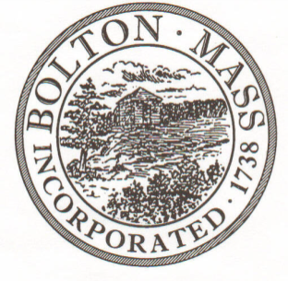
PUBLIC MEETING NOTICE
TO OFFICE OF THE

Received by Town Clerk:

Date: _______________________________

Time AM/PM

Posted by Town Clerk - Town Hall and Website:

Date: _______________________________

Time AM/PM

BOLTON TOWN CLERK

TIME STAMP
BOARD: | HISTORICAL COMMISSION

MEETING PUBLIC HEARING (Please underline appropriately)

DATE: | 11/06/2019 |  | TIME: | 6:00PM

LOCATION: | Town Hall / Selectmen Room or 2nd floor Table

REQUESTED BY: | M. B. Remington, Chairman | Date filed  to TC: | 10/21/2019

NOTE: Notices and List of Topics or Agendas are to be posted 48 hours in advance of the meetings excluding Saturdays, Sundays and legal holidays. Please keep in mind the Town Clerk’s hours of operation and make necessary arrangements to be sure your posting and agenda is made in adequate time.

LIST OF TOPICS / AGENDA

Updates/Public Comment:
Minutes – 10/02/19
Pan Cemetery – 10/19 monument straightening report
Town Hall portico repairs
Indigenous Peoples program at Acton Public Library on 10/10

Administrivia:
Mail –
Budget Report –Bolton Historical Society membership renewal
BHC Membership – continue the search for 2 new members

New Topics/Public Discussion:
369 Old Bay Road building permit
Student project – Pan Cemetery

