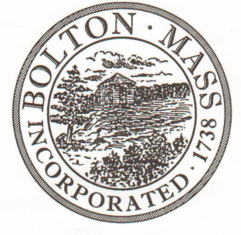
PUBLIC MEETING NOTICE
TO OFFICE OF THE

Received by Town Clerk:

Date: _______________________________

Time AM/PM

Posted by Town Clerk - Town Hall and Website:

Date: _______________________________

Time AM/PM

BOLTON TOWN CLERK

TIME STAMP

BOARD: | Board of Assessors

MEETING PUBLIC HEARING (Please underline appropriately)

DATE: | April 24, 2018 |  | TIME: | 6:00 PM

LOCATION: | Town Hall, Upstairs Side Table

REQUESTED BY: | Cynthia Bradbury,  Assistant Assessor | DATE: | 04/09/2018

NOTE: ALL MEETING NOTICES AND LIST OF TOPICS MUST BE FILED AND TIME STAMPED IN THE TOWN CLERK’S OFFICE AND POSTED 48 HOURS IN ADVANCE OF THE MEETINGS EXCLUDING SATURDAY, SUNDAYS AND HOLIDAYS.

LIST OF TOPICS

- Review FY2019 market trends / tax rate projection with David Manzello. David Manzello attend partial Board meeting (for this topic).
- Discuss Cyclical Inspection during the summer - 2018.
- Board and Cynthia complete the qualitative review of response(s) received for the “RFQ for Valuation Services FY2019 – FY2021” - advertised on March 8, 2018.
- General Departmental business and signatures.

