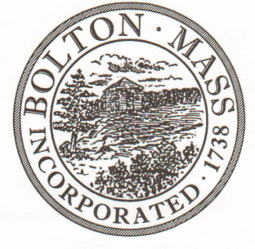
PUBLIC MEETING NOTICE
TO OFFICE OF THE

Received by Town Clerk:

Date: _______________________________

Time AM/PM

Posted by Town Clerk - Town Hall and Website:

Date: _______________________________

Time AM/PM

BOLTON TOWN CLERK

TIME STAMP

BOARD: | Board of Assessors

MEETING PUBLIC HEARING (Please underline appropriately)

DATE: | November 5, 2019 |  | TIME: | 6:00 PM

LOCATION: | Town Hall, Board of Selectmen Room

REQUESTED BY: | Cynthia Bradbury,  Assistant Assessor | DATE: | 10/22/2019

NOTE: ALL MEETING NOTICES AND LIST OF TOPICS MUST BE FILED AND TIME STAMPED IN THE TOWN CLERK’S OFFICE AND POSTED 48 HOURS IN ADVANCE OF THE MEETINGS EXCLUDING SATURDAY, SUNDAYS AND HOLIDAYS.

LIST OF TOPICS

- Begin meeting in Open Session.

- Executive Session pursuant to M.G.L. c.30A, Sec.21(a)(8) to consider or interview applicants for employment by a preliminary screening committee if open meeting will have a detrimental effect in obtaining qualified applicants.

